
https://atlas.cid.harvard.edu/

Optimal Industry Development Strategy Using Economic and Product Complexity

India

─
The Economic Complexity Lab - Columbia University
Haoxian Chen, Davepriyan Gunaratnam, Rohan Macherla, Ajit Akole, Shomik Ghose, Alex Wei-Liang Ku, Sannidhya Modi, Xilin Wang, Alexandra Garcia, Kelly Mi, Alex Chung, Margarita Demkina
Optimal Industry Development Strategy for India

0. Executive Summary

In this report, we aim to uncover the economic path India went through during the period from 2013 to 2018. Specifically, we dive into the topic through a macroeconomic overview of India from the perspective of Gross Domestic Product (GDP) and Economic Complexity Index (ECI), which reflect countries’ production capability and production structure, respectively. We find that during the period of our interest, India demonstrated a high level of economic growth with an annual GDP growth rate of 7.75%, concurrent with a decrease in economic complexity as compared with other emerging economies. Average annual GDP growth decreased to 4.39% between 2019 to 2021, but economic complexity increased significantly, thus showing similarly mixed results to other emerging economies during this period.

The mixed progress during the period, we believe, can be partially explained through analysis of the economic and product complexity structure of India on the industry group level. The product classification system we adopt allows us to measure the realized industry development for various industry groups and to observe that India consistently relied on developing the Transportation, High-Complexity Products, and Daily Instruments industries during the period of 2013 to 2018, while its developed counterparts and emerging economies around the globe adopted more complex and progressive paths. Regarding the post-COVID increase in economic complexity coupled with a slower GDP growth as observed in 2021, we determine that India chose to continue its development of higher complexity industries such as High-Complexity Products and Services and Utilities while sacrificing a potentially higher GDP growth associated with fulfilling global demand for basic, low-complexity products during the pandemic period.

Based on our analysis of the opportunity gain and a sensitivity analysis of major industry groups, India can further its gains by prioritizing High-Complexity Products, Transportation, and Machinery. We further note that India has a slightly mismatched development strategy that indicates a low level (compared to other emerging economies) of structural optimality on the complexity level, having an adjusted R-square of around 12.6% in 2018. However, in 2021, adjusted R-square decreases to 1.73%, indicating an even lower level of structural optimality relative to other emerging economies. Since a significant positive correlation exists between five-year GDP growth and the structural optimality index of an economy as we define and calculate, India indeed has a suboptimal growth experience as compared with fast-growing economies both on a regional scale and on a global scale, and has the potential to further its economic gains through industrial structural optimization as suggested in the paper.

1. Report Overview

In this report, we aim to uncover the economic path India went through during the period from 2013 to 2018, and the impact of COVID-19 on its economic development as observed in 2021. Specifically, we dive into the topic through a macroeconomic overview of India from the perspective of Gross Domestic Product (GDP) and Economic Complexity Index (ECI), which reflect countries’ production capability and production structure, respectively. We then analyze the industrial framework and changes of India during the period based on quantitative measures such as Product Complexity Index (PCI) and Product Family Complexity Index (PfCI), followed by a detailed analysis of how such changes have matched with development strategies as quantitatively measured by opportunity gains on an industry-level. We conclude our report with macro-level results and predictions of India, as deduced from regression models we have established on a global scale, which take into account countries’ stances in their product space.

2. Macroeconomic Results

2.1 GDP Ranking and Changes
Figure 1 illustrates the time-series GDP results for India and three of its peer countries (Russia, China, Japan) from 2013-2018. Similar to China, and in contrast to Russia and Japan, India displayed steady, upwards growth over all years. This is confirmed by India’s average annual growth rate of 7.75% over the five-year period, which is clearly higher than that of Russia (1.31%) and Japan (1.46%), and similar to that of China (7.18%).

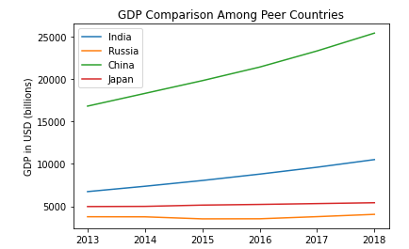

Figure 1: GDP Comparison Among Peer Countries (2013-2018)

Figure 2 illustrates the time-series GDP results in 2019-2021. Similar to Russia and China, India displayed upward growth over the period, despite an observed slight decrease in GDP in 2020 due to the economic implications of COVID-19. India displayed an overall decrease of 3.36% in average annual growth rate, down to 4.39% from the previous 2013-2018 period; similarly, Japan showed a 2.68% decrease relative to the previous period, but ended up with a negative growth rate of -1.22%; on the contrary, Russia, showed a period-over-period increase of 1.1% (up to 2.41%) and China showed an increase of 0.69% (up to 7.87%).
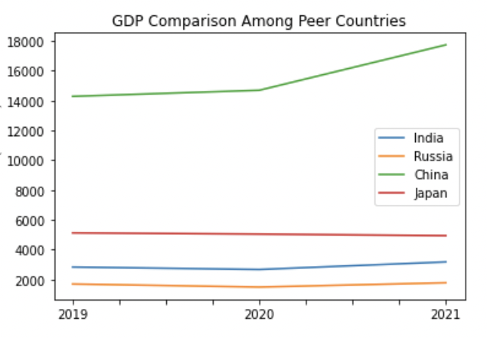
Figure 2: GDP Comparison Among Leading Economies (2019-2021)

2.2 ECI Ranking and Changes
The Economic Complexity Index (ECI), as defined by Ricardo Hausmann and Cesar Hidalgo in 2009 explains the knowledge accumulated in a country's population. In contrast to its GDP growth, which is the highest among its peer group, India’s ECI change is the lowest of its peer group. As illustrated in Figure 3 below, India (-40.35% ECI change) exhibits a decrease in terms of its production capability from 2013 to 2018, which is lower than that of Russia (64.66%), China (-13.27%), and Japan (-8.79%).

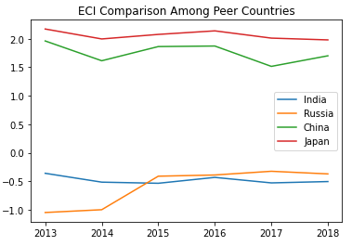

Figure 3: ECI Comparison (2013-2018)

However, as shown in Figure 4, India exhibits a significant increase in production capability from 2019 to 2021, similarly to Russia. China and Japan, on the other hand, experienced comparable decreases in production capability over the period, as marked by a sharp decline following 2020.

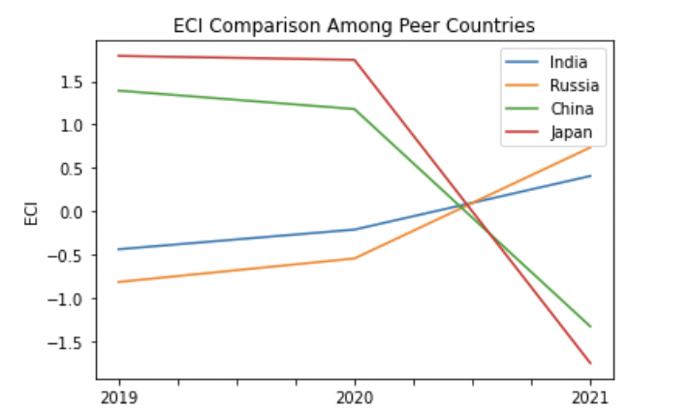
Figure 4: ECI Comparison (2019-2021)

Figure 5 offers a further comparison of GDP Growth and ECI over the time span from 2013 to 2018 for India. The increase in GDP during the period from 2013 to 2018 is accompanied by a volatile eventual decline in ECI. The results show that the economic growth experienced by India during the period from 2013 to 2018 is not very consistent with the predictions by ECI and India did not effectively make strides to develop a competitive product space that helps to accumulate complicated knowledge and technology. In order to provide a more concrete answer to why this has happened, we will dive into an analysis of India’s production structure and its product space designs in the next few chapters.

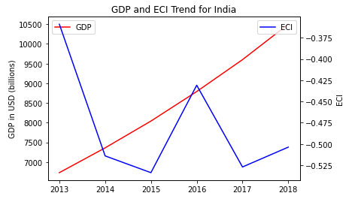

Figure 5: GDP Growth and ECI (2013-2018)

Figure 6 compares GDP Growth and ECI between 2019 and 2021 for the UK. The decrease followed by a sharp increase in GDP growth during the period from 2019 to 2021 is accompanied by an accelerating increase in ECI. The COVID-19 pandemic in 2020 necessitated a prioritization of low complexity industries as demand for basic, essential products replaced that of higher-complexity, discretionary products. India chose to continue its development higher complexity industries over the period, thus sacrificing GDP in 2020 but consistently attaining a higher ECI over this period.

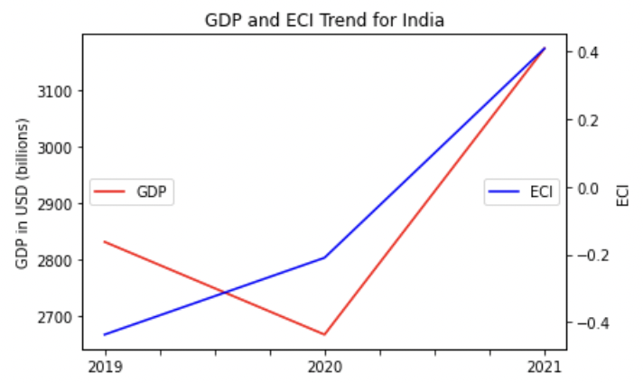
Figure 6: GDP Growth and ECI (2019-2021)

3. Production Analysis

3.1 Product Categorization
Our main data source in this research is the UN Comtrade Website (https://comtrade.un.org), which provides us with valuable information on countries’ export values on an annual basis, including highly specific export data for more than 5000 categories of products. In order to have a holistic vision of the product space of a country, however, a level of categorization is required. Products in our data source are labelled from 010000-999999, with the first two-digits representing a general category to which the product belongs. Based on the 99 categories as extracted from the label, we further group the products into 18 most widely-accepted industries, as summarized in Table 1.

Note that the High-complexity Products industry group is not a distinct industry but rather an aggregated industry that encompasses the most complicated products from the most technologically-advanced industries (as measured by PCI). This industry serves as an indicator for us to quantitatively evaluate how well a country has performed in developing cutting-edge technologies and closing its technical gap with advanced economies, which has become a topic of wide concern today. Indeed, when we rank the 18 categories based on PfCI (an equivalent concept of PCI as calculated based on the 18 categorized product groups), the High-complexity Products industry has the highest PfCI among all industry groups.

Category | Description
Animals and By-products | All kinds of meat, livestock and related by-products
Vegetables, Fruits and Plants | All kinds of plants, edible vegetables and fruits
Food and Preparations | Edible preparations, raw cooking materials and appliances
Clothing and Accessories | All kinds of fabrics, filament, clothing and accessories
Textiles | All kinds of textile articles and related products
Wood Products | Book, paper and other elementary products related to wood
Metals | Mining of all sorts of raw Metals
Refined and Processed Stones | Refined or processed stone products such as pearl and ceramics
Energy Drilling and Mining | Mining industry for energy, minerals, stone materials, etc.
Daily Instruments | Basic daily instruments such as sport requisites, timing and measuring tools
Raw Manufacturing | Basic products made from plastic, rubber, leather, etc.
Chemical Manufacturing | Advanced chemical products and pharmaceutical products
Chemicals | Raw chemical materials and by-products
Machinery and Construction | Machinery and mechanical appliances, including electrical equipment
Transportation | Vehicles and locomotives including aircraft, ship, railway, etc.
Weapons | Explosives, arms and ammunition
Services and Utilities | Financial, business, legal, communication, travel Services and Utilities, etc.
High-complexity Products | Agglomeration of advanced products with highest PCIs

Table 1: Categorization of Products

We further observe a positive correlation between the GDP and the export of High-complexity Products. A higher adjusted R-square exists between GDP and High-complexity Products exports, indicating that more successful economics, as measured by GDP, tend to be those that are capable of producing and exporting High-complexity Products as we define them. The Figure 3 and 4 show the OLS results in a universe of 107 and 21 typical countries respectively.

 | High-complexity Products | Food and Preparations | Animals and By-products
Adj.R-squared | 0.075 | 0.006 | 0.002
F-statistic | 9.556 | 1.638 | 1.175
No. Observations | 107 | 107 | 107

Figure 3: OLS Regression Results of GDP against Percentage Volume of Exports

 | High-complexity Products | Food and Preparations | Animals and By-products
Adj.R-squared | 0.149 | 0.003 | -0.012
F-statistic | 4.510 | 1.059 | 0.7542
No. Observations | 21 | 21 | 21

Figure 4: OLS Regression Results of GDP against Volume of Percentage Exports

3.2 Realized Industry Development
Based on the product categorization aforementioned, we aim to capture India’s realized industry production strategy between 2013 and 2018 on a complexity level. In Hausmann and Hidalgo (2009), distance is defined to be a measure of how far a country is from a certain product not in its product space. We extend this concept to all product groups and quantify how technically equipped a country is to develop the corresponding product groups. In other words, the shorter the distance between a country and a product group, the more capable a country is in developing products within that group. Defining this net distance change as the Realized Industry Development (RID), our export data allow us to calculate and compare RID of US and the 18 product groups in 2013 and 2018 through subtraction, where a positive RID indicates a shortening of the distance (i.e., advancement of the industry), and a negative RID indicates the reverse.

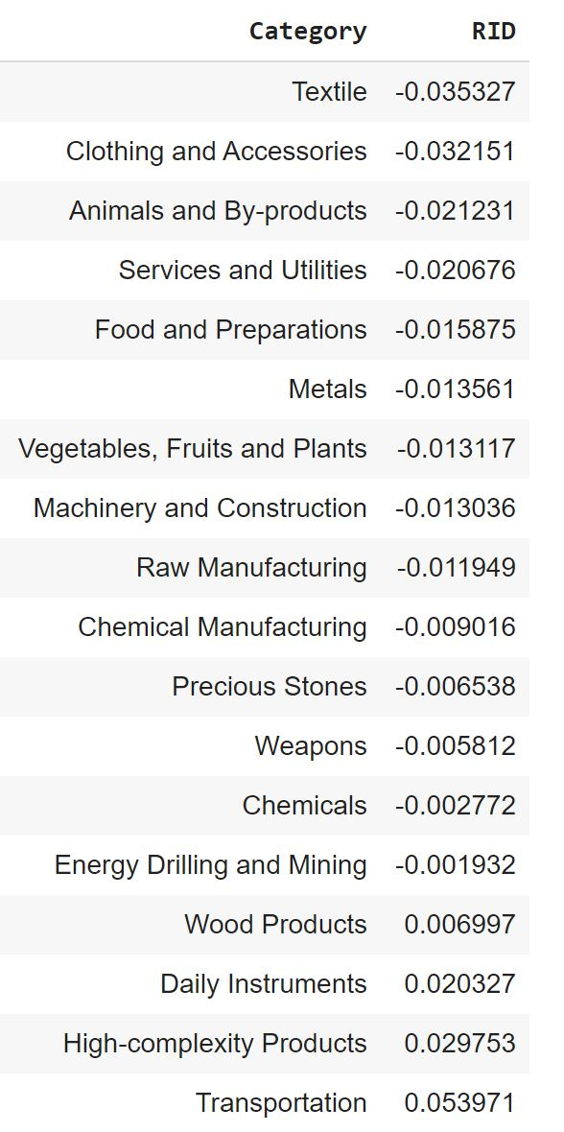
Table 2: Realized Industry Development (RID) of India (2013-2018)

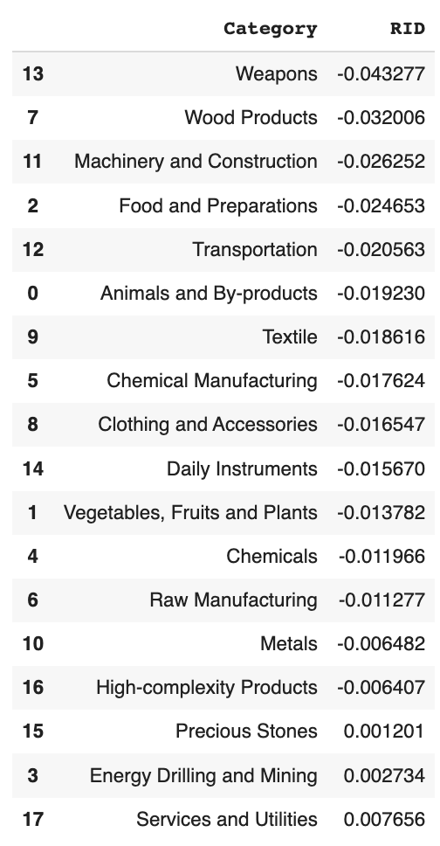
Table 3: Realized Industry Development (RID) of India (2019-2021)

Between 2013 and 2018, India shows advancement in four of the product groups, with positive RIDs pertaining mostly to high-complexity industries. Between 2019 and 2021, India demonstrates slight advancement in only three industries but still manages a higher ECI.

3.3 Regional and Global Comparison
Table 3 and 4 below summarize how the production strategy adopted by India compares with leading economies and a selected group of emerging economies in the world, as measured in RID.

Ranking | France | the UK | Germany
1 | High-complexity Products | Services and Utilities | High-complexity Products
2 | Chemical Manufacturing | Weapons | Transportation
3 | Daily Instruments | Raw Manufacturing | Wood Products
4 | Animals and By-products | Precious Stones | Metals
5 | Food and Preparations | Animals and By-products | Food and Preparations
Table 4a: RID Comparison across Leading Economies (2018)

Ranking | France | the UK | Germany
1 | Services and Utilities | Precious Stones | Daily Instruments
2 | Precious Stones | High-complexity Products | Transportation
3 | High-complexity Products | Services and Utilities | Chemicals
4 | Energy Drilling and Mining | Energy Drilling and Mining | Chemical Manufacturing
5 | Machinery and Construction | Wood Products | Clothing and Accessories
Table 4b: RID Comparison across Leading Economies (2021)

Ranking | China | South Korea | Singapore
1 | High-complexity Products | Transportation | Transportation
2 | Transportation | Textile | High-complexity Products
3 | Machinery and Construction | High-complexity Products | Precious Stones
4 | Energy Drilling and Mining | Chemical Manufacturing | Daily Instruments
5 | Daily Instruments | Machinery and Construction | Services and Utilities
Table 4c: RID Comparison across Emerging Economies (2018)

Ranking | China | South Korea | Singapore
1 | Chemicals | Chemicals | Weapons
2 | Daily Instruments | Daily Instruments | Energy Drilling and Mining
3 | Transportation | Transportation | Transportation
4 | Raw Manufacturing | Textile | Machinery and Construction
5 | Weapons | Raw Manufacturing | High-complexity Products
Table 4d: RID Comparison across Emerging Economies (2021)

Table 4d further examines India’s development strategy against those of emerging economies on a global scale. Reasonably, emerging economies such as China, South Korea, Singapore and India have devoted the majority of their efforts into intermediate industry groups while developed economies such as the UK should have relied more on advanced industry groups. This trend holds true in general, regardless of the continent or the time period, and serves as an indicator for which phase of development a country is currently in as evaluated from its production strategy. Based on this standard, UK is indeed adopting a moderate but slightly out-of-phase strategy that seeks development in industry groups with a lower level of complexity than it should.

4. Product Space Design

4.1 Suggested Development Vector
As aforementioned, distance gives us an idea of how far each new product is from a country’s current mix of exports. As defined in Hausmann and Hidalgo (2009), distance is “the weighted proportion of products connected to goods p that country c is not exporting, i.e., MCP=0.” Based on this definition, the distance between a country and any product that the country is currently exporting (i.e., the country is a significant exporter in the product as compared to global average) is zero. Similarly, opportunity gain quantifies the contribution of a new product in terms of opening up the doors to more and more complex products. Intuitively, a product that a country is currently exporting (i.e., MCP=1) has an opportunity gain of zero. And unreasonable investment on certain product p would lead to a relative decrement in export of more profitable products, and therefore lead to a negative opportunity gain of product p. The opportunity gain is not the only estimator of a country’s level of economic development. However, among countries with comparable economics strength, those having higher ECI, or in other words, more reasonable economics structures are often in better shape.

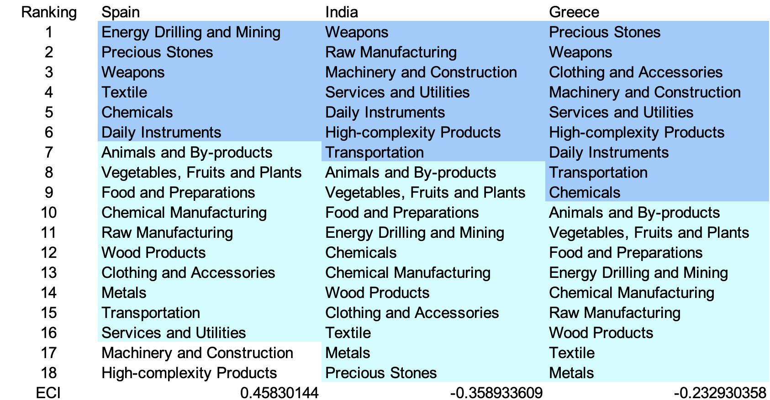

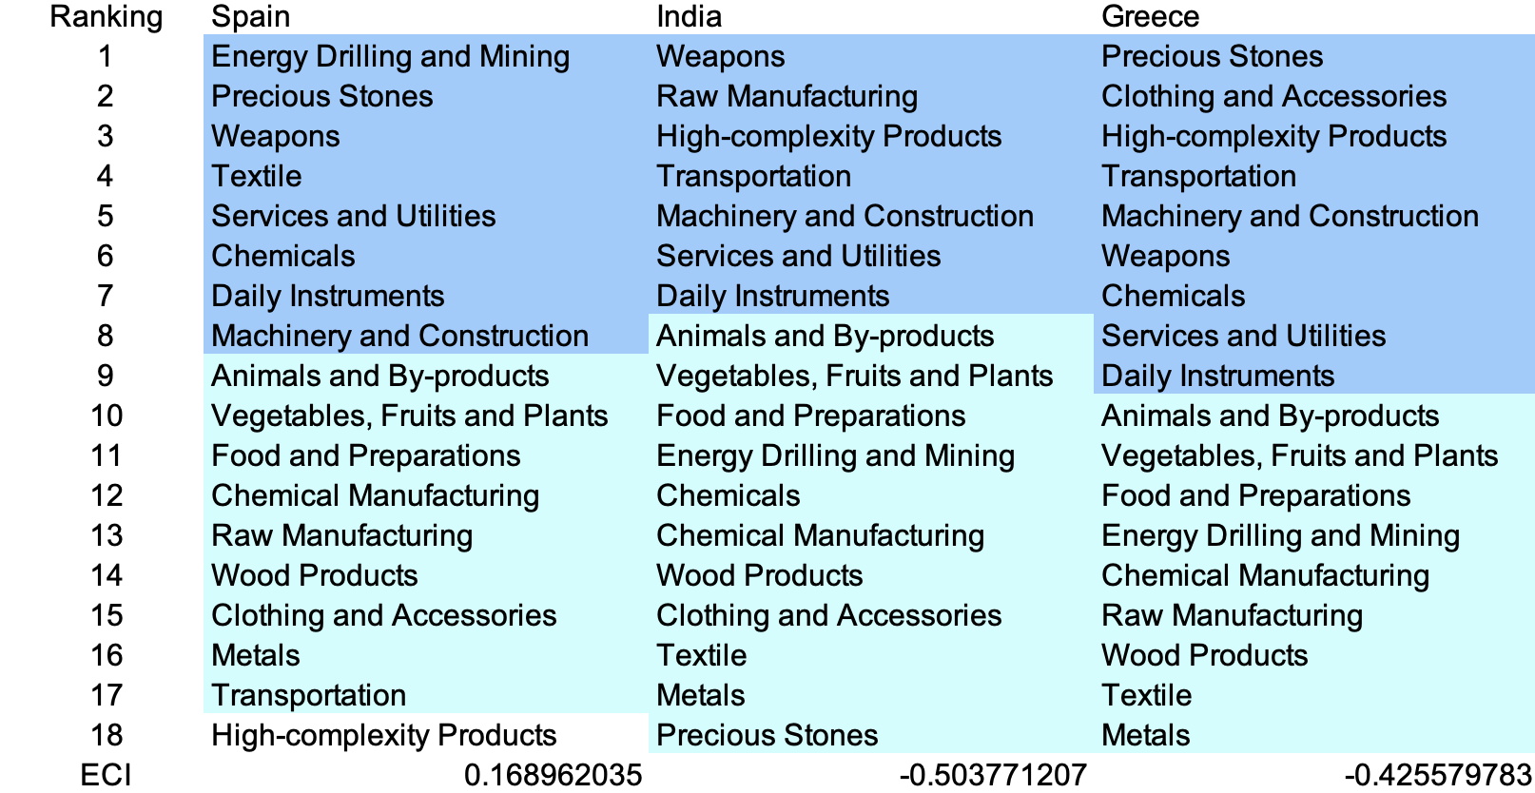

Table 5: SDV of High E_{f}CI Countries 2013(up), 2018(down)

We define the ranking of opportunity gain for a country c, as the Suggested Development Vector (SDV) of c. Table 5 and 6 summarize how the SDV of Brazil compares with a selected group of comparable and leading economies in the world, with the industry groups ranked in decreasing order of significance. Dark blue indicates positive opportunity gain, light blue indicates zero opportunity gains, and white indicates negative opportunity gains. The result shows that leading countries barely have any industries with positive opportunity gain. In other words, those countries are already in the most stable and efficient economic structure. Without the necessity of economic transition, those countries merely need to maintain a steady and balanced economic development. In contrast, developing countries have nearly half of industries with positive opportunity gain, and share common interests in industrial manufacturing and High-complexity Products industries. It can be concluded that India shares the characters of developing countries, with a balanced economics structure that leans towards intermediate-level industries. We focus on SDV results for 2018 because they give the most accurate snapshot of complexity for global comparison in the absence of the irregular effects of the COVID-19 pandemic observed in 2021.



Table 6: SDV of Other Typical Countries 2013

4.2 Budgeted Industry Development Strategy and Interpretation

The optimal budgeted industry development strategy aims to solve the most efficient allocations under the budgeted constraint of different situations of heuristic total export growth. In order to obtain such an allocation portfolio, we formulate an optimization problem as the following:



where k(x) is the second largest eigenvector of $M_{CC'}$ after adding $x$ to the original export vector, C is the country that we are interested in, P is the product space, B is the heuristic budget.

If we can solve this problem, then we can know what the largest ECI that a country can improve to. Accordingly, the optimal solution $x*$ that we obtain here is exactly our optimal allocation. However, the biggest problem is that the objective function is not convex. Therefore, we cannot apply the classical tools for convex optimization on this problem. In order to solve this problem, our idea is to use greedy algorithm. The way that we apply greedy algorithm is that firstly we separate the total budget into k equal parts, and then for the first equal part we try to search for the product that can optimize our objective function by iterating through each $p∈P$. After we find the optimal product p for this equal part, we add the amount back to the export value of this product p and update the ECI for this country. If we observe that ECI does not change after iterating all the products, then we can add up one more equal part to invest. Until we find there is an ECI increment, we add the amount now to that product. The rest equal parts can be done in the same way.

However, as is known to all, greedy algorithm is a kind of local search algorithm, which is pretty possible to run into a local minimum. Therefore, for local search algorithms, one typical way is to keep it away from the local minimum is to enhance the vision of the algorithm by looking more steps forward. In our setting, whenever we obtain an increment of ECI, we mark down the required amount of export growth. Simultaneously, we continue searching for the next ECI increment point, compare the ratios of these two possibilities and pick the largest one. The ratio is defined as the following:


where ${ECI}_{p}$ is just the ECI of the country after adding some amount of export increment to product $p$, which is exactly the amount that is able to make ECI change. Also, we can express it in the way of $||$$x_{p}-x_{0}$${||}_{1}$.

In this way, we can obtain a further sighted greedy algorithm. Also, the number of parts that we would like to separate the budget into also matters. In order to solve this problem, we added a stabilizer on top of the enhanced greedy algorithm, by running the algorithm for different numbers of parts and selecting the portfolio with the largest ECI increment and most complex economic structure.

Besides, it is quite common that there is a surplus for the budget. To deal with the surplus, we just add it to the product which needs the least amount of dollar to make $M_{cp}$ = 1, (i.e., the smallest amount of required export increase).

Interpretation:

For the purpose of a clear explanation of the line charts, we try to label all the products in Table 7. Please refer to this table when trying to understand the investment trajectories in the line charts.

Label | Product Names
1 | Animal and By-products
2 | Vegetables, Fruits and Plants
3 | Food and Preparations
4 | Energy Drilling and Mining
5 | Chemicals
6 | Chemical Manufacturing
7 | Raw Manufacturing
8 | Wood Products
9 | Clothing and Accessories
10 | Textile
11 | Metals
12 | Machinery and Construction
13 | Transportation
14 | Weapons
15 | Daily Instruments
16 | Precious Stones
17 | High-complexity Products
18 | Services and Utilities

Table 7: Products Labeling

Below is the economic panel for India in 2013. We can see that for different percentages of heuristic total export growth, the ECIs of India actually have different amounts of increments. Overall, 5 percent export growth can result in a ECI improvement pattern starting from around -0.35 and ends at around -0.09. As the budget is increased to 10 percent export growth, the ECI of India can achieve a slightly higher level, which is around 0.03. With much more growth budget, like 15 or 20 percent growth, India is able to achieve an even much higher stage, which is around 0.23 or even 0.91.
For the case of 5 percent export growth, the portfolio is mostly made up of raw manufacturing, and services and utilities. For 10 percent export growth, in addition to the products mentioned before, weapons and daily instruments are added as main components as well. As the budget increases to 15 percent, the portfolio becomes much more diverse. The primary industries contained are machinery and construction, daily instruments and raw manufacturing. When the budget increases up to 20 percent, the portfolio becomes pretty comprehensive, where metals is also added as an essential industry for development. In addition to the products mentioned before, other products including chemical manufacturing and high-complexity products are also taken into account. In these four ECI improvement trajectories, we also notice that the largest improvement comes from raw manufacturing and services and utilities, suggesting that with a low economic improvement anticipation, India should focus more on developing these products. A more detailed numerical representation of the portfolio is shown in Table 8.
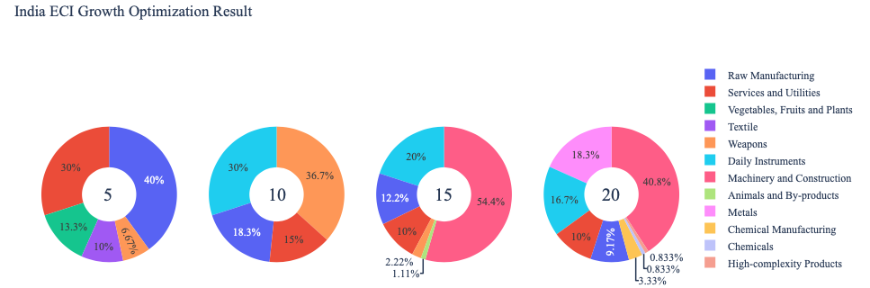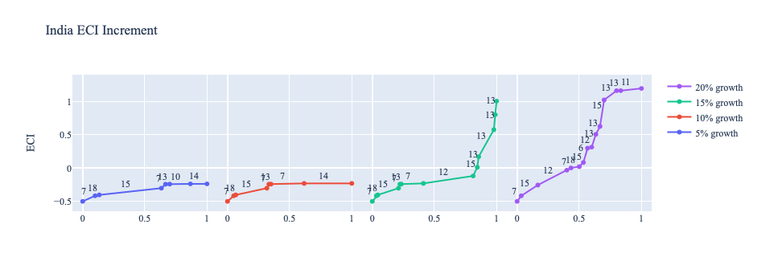
Figure 5: Greedy Based ECI Improvement Results of India in 2013 with Different Budgets

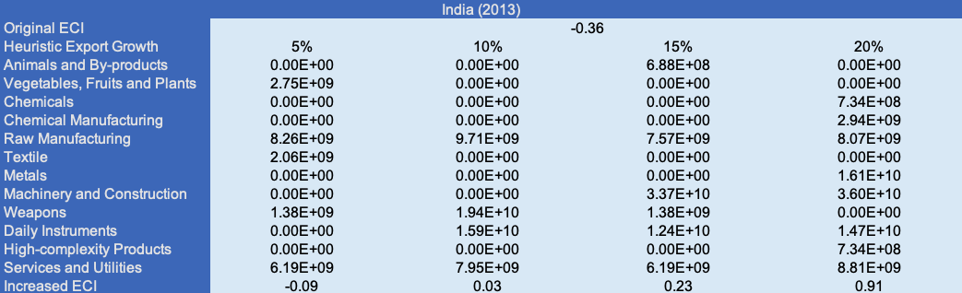

Table 8: Portfolio of India in 2013

For further suggestions on India’s development in the future. We also offer the optimization result based on its export data in 2018. Below is the economic panel for India in 2018. For the cases of 5 and 10 percent growth in export, even though the ECI improvement trajectories are not so different, the main components in the portfolio are quite distinguishable. For 5 percent, daily instruments and textile are the main components, while for 10 percent, weapons and raw manufacturing are the main ones. As the budget increases to 15 percent or 20 percent export growth, the ECI of India boosts to a much higher level, from -0.50 to 1.00 or even 1.20. When the budget is 15 percent export growth, machinery and construction, raw manufacturing, and daily instrument takes up most of the allocation. However, after the budget is increased to 20 percent, the portfolio becomes much more balanced, showing that machinery and construction, daily instrument, transportation, and metals are the primary components and their weights are similar. A more detailed numerical representation of the portfolio is shown in Table 9.

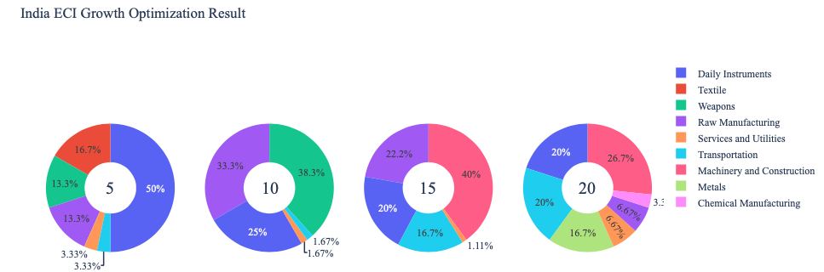
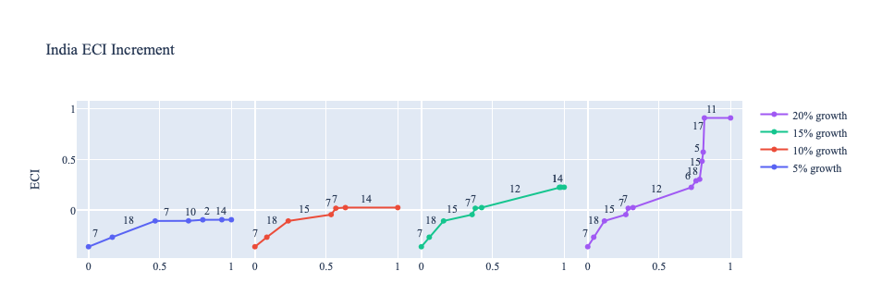

Figure 6: Greedy Based ECI Improvement Results of India in 2018 with Different Budgets

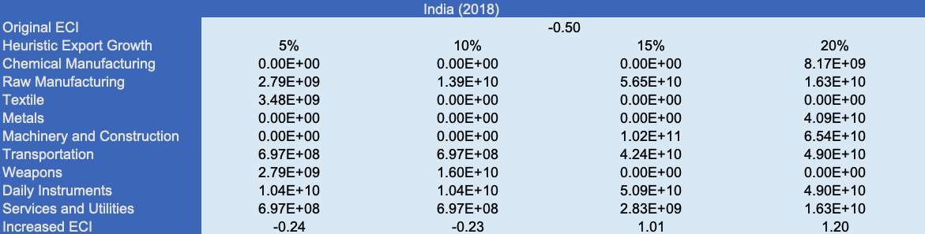

Table 9: Portfolio of India in 2018

Updated export data for 2021 yields the following ECI improvement trajectories for India. ECI notably improves with 5 and 10 percent export growth, and slightly increases with 15 percent export growth, then plateauing for 20 percent export growth with a maximum ECI of 0.74 (up from 0.408). The landscape of industries is completely different from 2013 and 2018, obtaining a sole focus on Food and Preparations, Textile, and Energy Drilling and Mining. Textile and Energy Drilling and Mining are shown to contribute the most to ECI improvement, despite having a lower complexity than industries suggested in previous years. This implies that India spent 2019-2021 prioritizing higher complexity industries despite them not being particularly conducive to maximizing their ECI. That is, there is greater opportunity gain for India in the aforementioned industries at its current stage in development and given the economic effects of the pandemic. 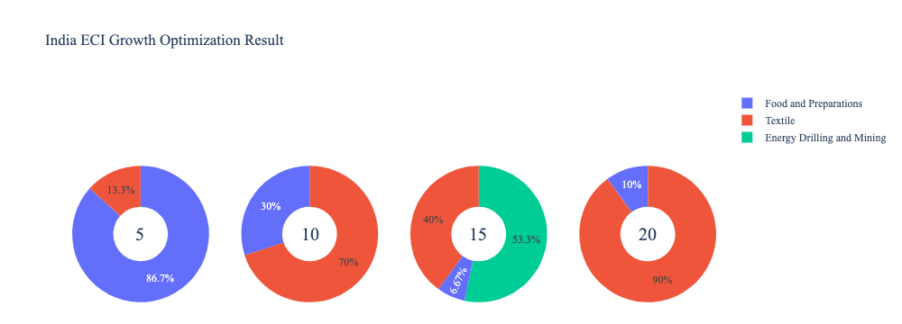
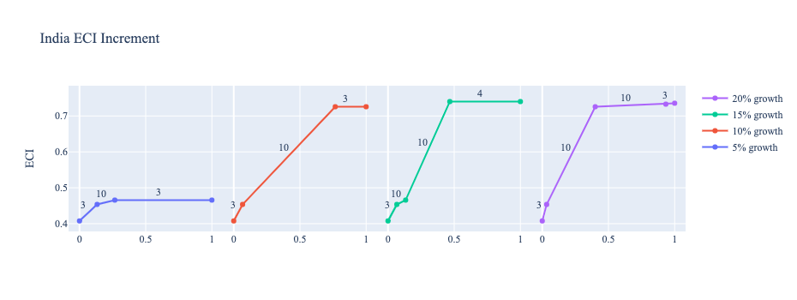
Figure 7: Greedy Based ECI Improvement Results of India in 2021 with Different Budgets

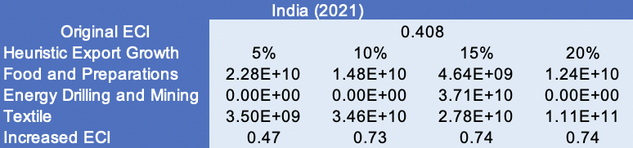
Table 10: Portfolio of India in 2021

4.3 Sensitivity Analysis and Contingency Strategy
In the following section our broad aim is to understand how sensitive India is to changes in export in various industries. While the Economic Complexity Index has been shown to contain valuable information about the economic strength/capacity of a country, little has been said as to the stability of the measure itself. We seek to uncover the main drivers of stability under a country's ECI score and better understand longer-term projections for ECI growth. Additionally, gaining an intuition on the industries that are bolstering an economy and the industries that offer the greatest return per unit of investment is best done through visualization of industry specific sensitivity. To this end, we have developed two categories of sensitivity analysis.
ECI Sensitivity Graph
Firstly, in order to assess the effect particular industries have on each respective country, we developed ECI Sensitivity graphs. We use shocking methodology to increment or decrement an industry’s export level by a certain percentage and recalculate the ECI all else being equal. While freezing the export dynamics of the rest of the world and enacting an instantaneous shock in export for a particular industry and country may not reflect real-life dynamics, what it does offer us is an understanding of a country’s level of dependency on an industry in the context of ECI. The shocking is done in small percentage increments in order to smooth out the resulting curve. Additionally, a recurring theme one will see is that for most industries, a breaking point occurs where the ECI either jumps upwards or downwards, creating a hockey stick shape rather than a linear trend. While the inflection point may not be accurate in context of real life, comparing the various inflection points across industries can give us valuable insight.
The graphs are formulated as follows: There are four ECI Sensitivity graphs. The first two represent data from 2018. The first chart shows positive shocking in which export numbers are shocked upwards per industry. The X-axis is in terms of percentage shock per current dollar value of export. The Y-axis is the recalculated ECI level post-shocking. The second chart follows the same format except the X-axis represents negative shocking. In other words, exports for each industry are decremented and the ECI is accordingly recomputed. The final two sensitivity graphs show the same results using 2013 data. Below is an example of an ECI sensitivity graph.

Example 2018 (Incremental ECI Sensitivity)

SDV sensitivity
Secondly, we analyze the sensitivity of the SDV to changes in export levels. The goal is to understand how export level changes for a particular industry can affect the marginal opportunity gain for other industries. We will be using specifically High Complexity Products and Food and Preparations as our base industries. We will be increasing or decreasing the absolute export level in both of these industries and observing the effects on the SDV.
When the opportunity gain of an industry is negative, the SDV sensitivity approximates how an over-development of the industry jeopardizes the economic structure of a country. When the opportunity gain of the industry is zero, the SDV sensitivity determines whether the further development of the industry shapes the country with a better economic structure and predicts how the SDV would change accordingly. Specifically, as we reduce the export of such an industry to 25%-50% of its original value, a few other industries originally with negative opportunity gain could likely become profitable.
Similar to the ECI sensitivity graphs above, we will be shocking export of High Complexity Products and Food and Preparations in small percentage increments. A new SDV, represented by a new column in the charts, is recorded only when a certain level of shock changes the structure of the SDV. In effect we are incrementing or decrementing export levels of two industries until the marginal opportunity gain of any industry changes in category (positive, negative, or neutral). Below is an example of a SDV Sensitivity chart with Positive Shocking. Industries with positive marginal opportunity gain are colored blue, neutral is colored white and negative is colored red.


Example High-complexity Products 2018 (Incremental SDV Sensitivity)

Contingency Plan
The Contingency Plan aims to present a set of solutions with respect to upheavals in different industries. Instead of compensating for the declining production directly, the best strategy is to develop those incipiently profitable industries. In this manner, we can derive the contingency strategy for countries to deal with possible abrupt declines of crucial industries. In some cases, the SDV remains unchanged even when a zero-opportunity-gain industry declines to its 20% in terms of export. We can then conclude the industry is not indispensable to the country. As a clarification, the three consecutive N/As means that the country doesn’t even need to respond to a collapse in the industry. Countries tend to have distinct solutions to the up and down of the same industry. To create the contingency strategy table we decrease the export level for each industry in the country’s current production space by 60% respectively. The three highest ranking industries in the new SDV are then returned.


Example Contingency Strategy 2018

4.3 Sensitivity Analysis Results and Interpretation

Below is India’s 2018 ECI Sensitivity Charts. Firstly in the positive chart, we notice immediately that increases in High Complexity Product, Transportation, and Machinery lead to increases in ECI. This is a common combination of industries for well developed countries. High Complexity Products offer the best ECI growth per unit of export increase. All other industries tend to not greatly affect the ECI level making it fairly clear which industries to pursue.

Next we consider India’s 2018 Negative Shock chart. We see that India is most sensitive to drawdowns in Chemical Manufacturing and Textiles. That being said, we see that India’s ECI is negative so reduction of export in some industries that are not helping the ECI score actually lead to significant increases in ECI level.

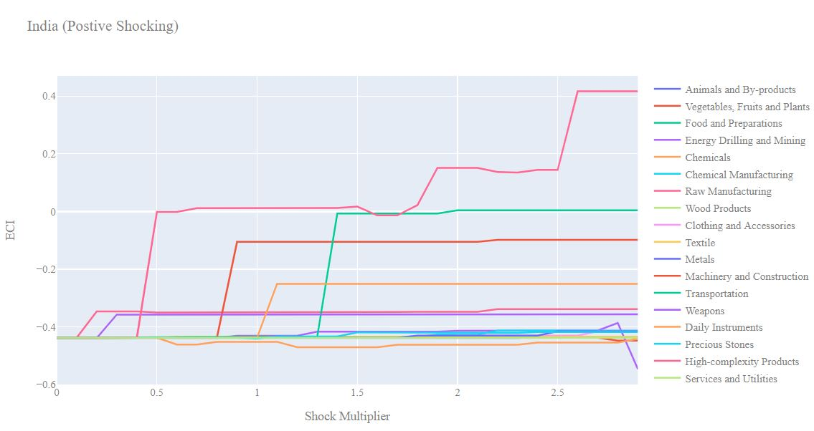
India 2018 (Incremental ECI Sensitivity)

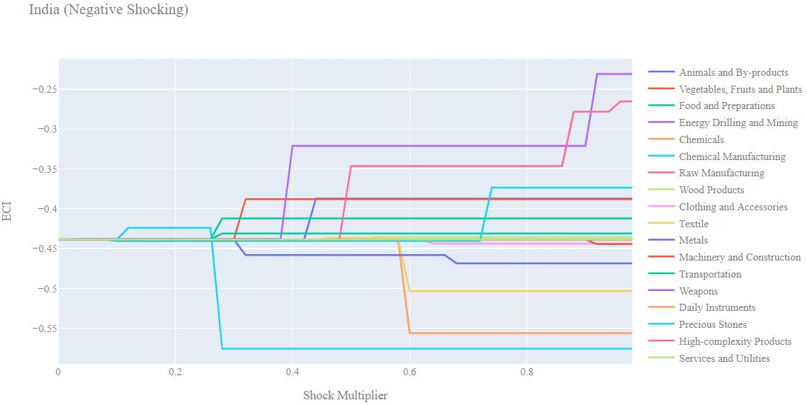
India 2018 (Decremental ECI Sensitivity)

Next we consider the 2013 ECI Sensitivity graphs. We see that in the positive shocking case, the landscape of ECI sensitivity has not altered significantly over the five year period. High complexity products seem to offer the best ECI growth prospects. Transportation and Machinery affect ECI levels positively as in 2018.

In the 2013 negative shocking case, we see that again India is sensitive to drawdowns in Chemical Manufacturing and Textiles. However in 2013 we see that India is also somewhat sensitive to drawdowns in Metals as well.
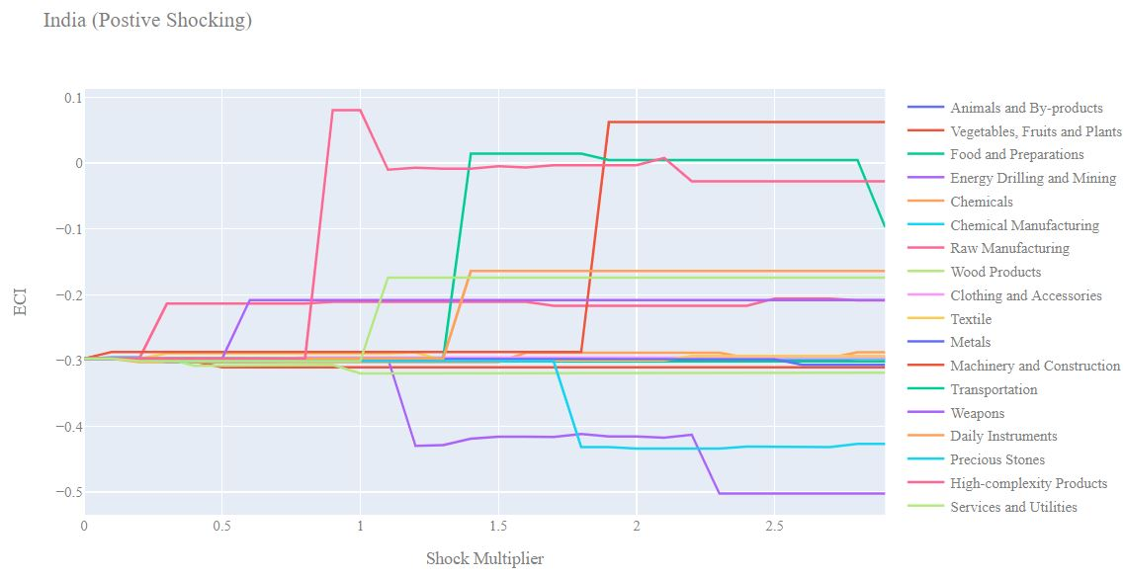

India 2013 (Incremental ECI Sensitivity)

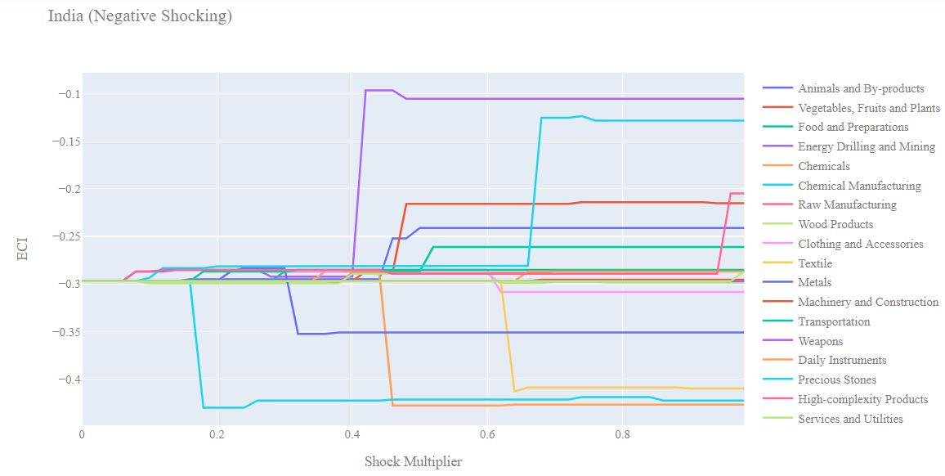
India 2013 (Decremental ECI Sensitivity)

Below we see the SDV sensitivity charts for High Complexity Products in 2018. India’s SDV is somewhat sensitive to changes in High Complexity products since the Indian economy is dependent on the export of products from this industry. If High Complexity Products are shocked upwards far enough we see that many industries start having negative opportunity gains since at that point India’s economy will become heavily dependent on High Complexity Products and the industries that are within close proximity.

Considering the Negative SDV sensitivity chart we observe that decreases in High Complexity Products only makes High Complexity Products an even more beneficial space to enter. This phenomenon is observed during the pandemic period, as India managed to increase its ECI despite the drawdown in High Complexity Products. We can see from the Food and Preparations SDV sensitivity chart that India is not especially dependent on this industry causing it’s SDV to be fairly stable in the face of shocks to this industry.

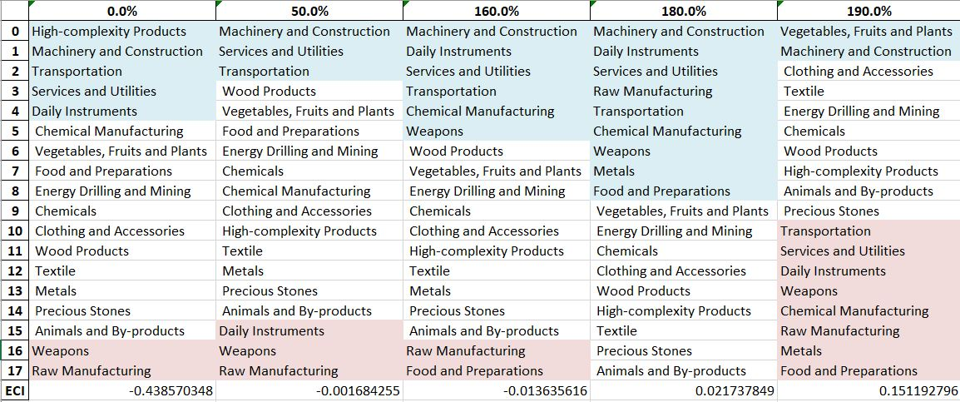

India High-complexity Products 2018 (Incremental SDV Sensitivity)

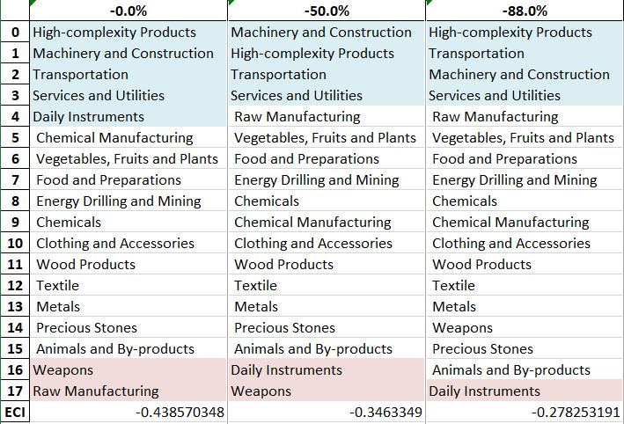

India High-complexity Products 2018 (Decremental SDV Sensitivity)

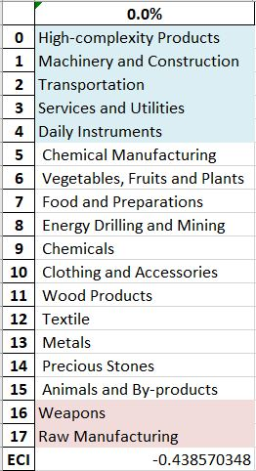

India Food and Preparations 2018 (Incremental SDV Sensitivity)

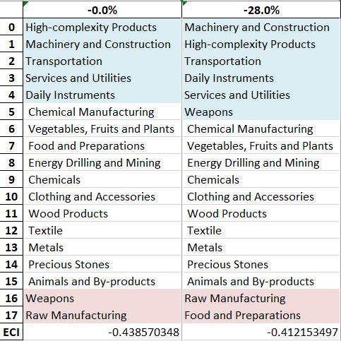

India Food and Preparations 2018 (Decremental SDV Sensitivity)

4.4 Contingency Strategy

Decreasing export of each industry in India’s 2018 production space by 60% respectively, we derive the contingency strategy shown below.

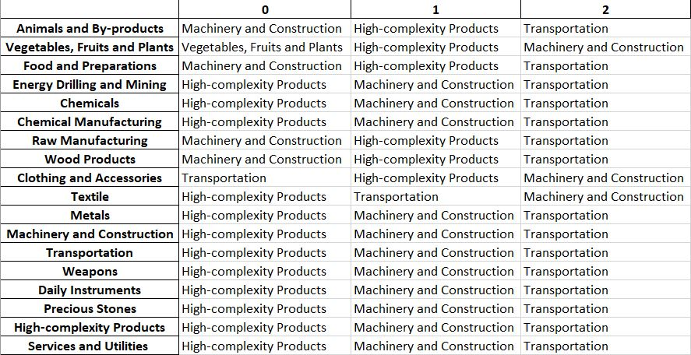
India Contingency Strategy 2018

Based on India’s RID for 2021, we note that the contingency strategy recommended by our algorithm in 2018 is closely mirrored by India’s development strategy over the course of the pandemic. As such, it supports the reasoning behind India’s increase in GDP and ECI between 2019 and 2021.

5. Macro-level Predictions

5.1 Structural Optimality Index
Indeed, such choice of prioritization has proven to be a significant factor in deciding the economic outcomes of countries. In order to quantitatively evaluate how effective our development strategies are and how deviations from the suggested developmental path will lead to suboptimal growth results, we define the measure – Structural Optimality Index (SOI) – on a country level as the Adjusted R-Square obtained from regressing the country’s realized industry development over the suggested development strategy. Both strategies are quantified in nature, with the realized development represented by export increase in every major industry group and the suggested development strategy represented by the opportunity gains of developing the corresponding industry groups as calculated in previous sections. The adjusted R-square from the regression thus provides us with a quantified measure of how the development path adopted by the country has fitted with/differed from calculations on a complexity level.

After obtaining this measure for all countries in our database, we further regress countries’ five-year economic growth, which is defined as the percent increase in GDP (USD), over their SOI. Figure 6 illustrates the regression output, which shows a strong positive correlation between countries’ SOI and their five-year GDP growth, significant at the 1% level and achieving an adjusted R² of 4.5%. In other words, the more a country develops as suggested by calculations on a complexity level, the better economic outcomes it achieves.

Table 18: OLS Regression Results
Dep. Variable: GDP | F-Statistic: 5.963
R²: 0.054 | Prob (F-Stat): 0.0163
Adj R²: 0.045 | No. Observations: 106

Figure 2: Regression of Five-year GDP Growth over SOI

5.2 SOI of India and Its Implications
India, for instance, has a lower level of structural optimality as compared with its emerging peers. As the regression in Figure 7 suggests (the orange curve represents export increase and the blue curve stands for opportunity gain of the corresponding industry), India demonstrates an average level of correlation with the suggested developmental path, having an adjusted R-square of around 12.6% in 2018 and 1.73% in 2021. India ranks in the second quartile among all countries in terms of SOI and makes a high rate of economic progress among its emerging peers from 2013 to 2018 with a 5-year GDP growth rate of 56.0%, which is somewhat consistent with the regression result in Figure 6. This is in direct contrast to developed economies such as Japan, where there is moderate SOI of around -4.8% and a corresponding 5-year growth rate of 9.0%, ranking it a slow-developing economy during the 2013-2018 period. In sum, India’s high economic progress from 2013 to 2018 is not fully explained by its deviation from our suggested developmental path. In fact, India invested heavily in the Transportation industry, while our model suggested focusing more on moderately complex industry groups such as Energy drilling/mining.

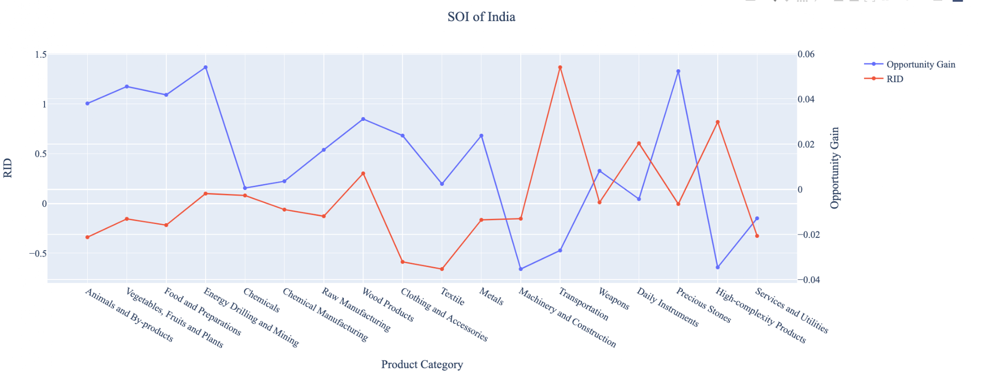
Figure 7: SOI of India (2013-2018)

In 2021, India ranks in the third quartile among all countries in terms of SOI and obtains an overall 3-year GDP growth rate of 13.17% between 2019 and 2021. Progress is slow on a global scale during this period, and India struggles to adjust to negative economic shocks by decreasing SOI and period-over-period GDP growth.

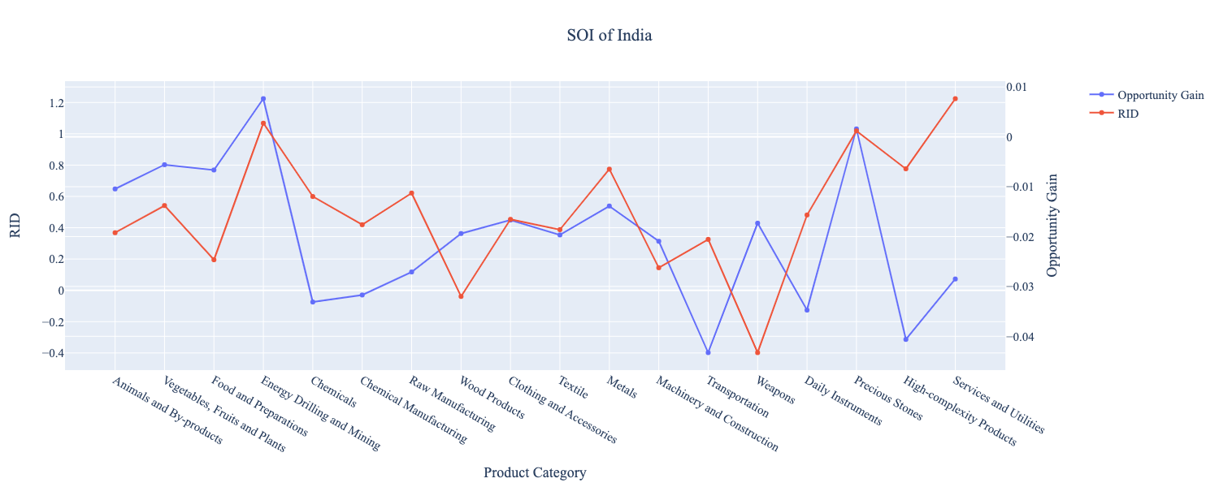
Figure 8: SOI of India (2019-2021)

6. Concluding Remarks

In conclusion, India has demonstrated a high level of economic growth in terms of annual GDP increase during the period from 2013 to 2018, concurrent with a decrease in economic complexity as compared with other emerging economies. In 2021, the economic effects of the COVID-19 pandemic can be seen in the India’s slowdown in GDP growth despite a significant increase in economic complexity.

The mixed progress during the period, we believe, can be partially explained through analysis of the economic and product complexity structure of India on the industry group level. The product classification system we adopt allows us to measure the realized industry development for various industry groups and to observe that India consistently relied on developing the Transportation, High-Complexity Products, and Daily Instruments industries during the period, while its developed counterparts and emerging economies around the globe adopted much more complex and progressive paths. In 2021, the mixed progress is a result of India prioritizing the development of higher complexity industries despite global demand for basic, low-complexity products. As such, its ECI increases, but its GDP increases at a slower rate than before and than some of its emerging counterparts.

Based on our analysis of the opportunity gain and a sensitivity analysis of major industry groups, India could further its gains by prioritizing High-Complexity Products, Transportation, and Machinery prior to the pandemic. Given the economic effects of COVID-19, India can further its gains by focusing on Textile and Energy, Drilling, and Mining. We further note that India has a slightly mismatched development strategy that indicates a low level (compared to other emerging economies) of structural optimality on the complexity level, having an adjusted R-square of around 12.6% in 2013-2018 and 1.73% in 2021. Since a significant positive correlation exists between five-year GDP growth and the structural optimality index of an economy as we define and calculate, India indeed has a suboptimal growth experience as compared with fast-growing economies both on a regional scale and on a global scale, and has the potential to further its economic gains through industrial structure optimization as suggested in the paper.

References

Hausmann, R., Hidalgo, C., Bustos, S., Coscia, M., Chung, S., Jimenez, J., Simoes, A. and Yıldırım, M. (2007). The Atlas of Economic Complexity. [online] Atlas.cid.harvard.edu. Available at: http://atlas.cid.harvard.edu/.

Balassa, B., “The Purchasing Power Parity Doctrine - A Reapprais- al,” Journal of Political Economy 72, 584-596 (1964).

Feenstra, R.; Lipsey, R.; Deng, H.; Ma, A. & Mo, H. “World Trade Flows: 1962-2000” NBER working paper 11040. National Bureau of Economic Research, Cambridge MA (2005).

United Nations Commodity Trade Statistics Database (http://comtrade.un.org/db/), accessed in August 2019.

The World Economic Forum, “The global competitiveness report,” (various years).

Barro, R. & Lee, J-W. “A New Data Set of Educational Attainment in the World, 1950-2010,” NBER Working Paper No. 1590 (2010).

Kaufmann, D. & Kraay, A. “Governance Indicators: Where Are We, Where Should We Be Going?” Policy Research Working Paper 4370. Washington, DC: World Bank (2008).

Hanushek, E.A. & Woessmann, L. “The Role of Cognitive Skills in Economic Development,” Journal of Economic Literature 46(3), 607- 668 (2008).

